Delta Lake Operations On Azure Databricks

Create a Delta Table
Step 1: Load CSV file into a DataFrame
file_path = "/Volumes/workspace/default/delta/export.csv"
df = spark.read.format("csv") \
.option("header", "true") \
.option("inferSchema", "true") \
.load(file_path) df.show(5)

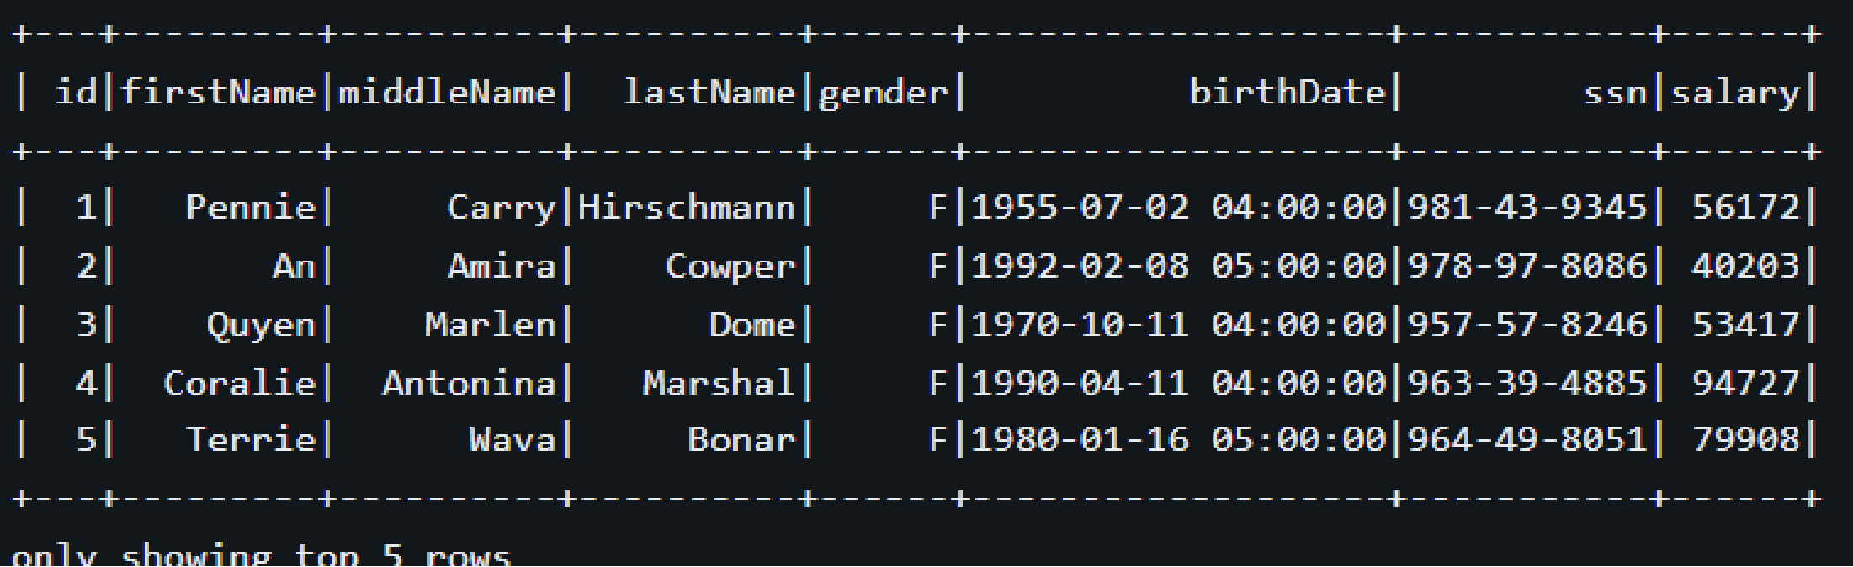

Step 2: Save DataFrame as a Delta table named 'employees'
df.write.format("delta") \
.mode("overwrite") \
.saveAsTable("employees")

Upsert (Merge) Data into the Delta Table
from delta.tables import DeltaTable
new_data = [ (3, "Quyen", "Marlen", "Dome", "F", "1970-10-11 04:00:00", "957- 57-8246", 55000), # Update salary for id=3 (6, "John", "M", "Doe", "M", "1985-05-10 04:00:00", "123-45- 6789", 60000) ]
columns = ["id", "firstName", "middleName", "lastName", "gender", "birthDate", "ssn", "salary"]
new_df = spark.createDataFrame(new_data, columns)
deltaTable = DeltaTable.forName(spark, "employees")
deltaTable.alias("old")
.merge( new_df.alias("new"), "old.id = new.id" )
.whenMatchedUpdate( set = {
"firstName": "new.firstName", "middleName": "new.middleName", "lastName": "new.lastName", "gender": "new.gender",
"birthDate": "new.birthDate", "ssn": "new.ssn",
"salary": "new.salary" } )
.whenNotMatchedInsert(values = {
"id": "new.id", "firstName": "new.firstName", "middleName": "new.middleName", "lastName": "new.lastName", "gender": "new.gender", "birthDate": "new.birthDate", "ssn": "new.ssn", "salary": "new.salary" } ).execute()

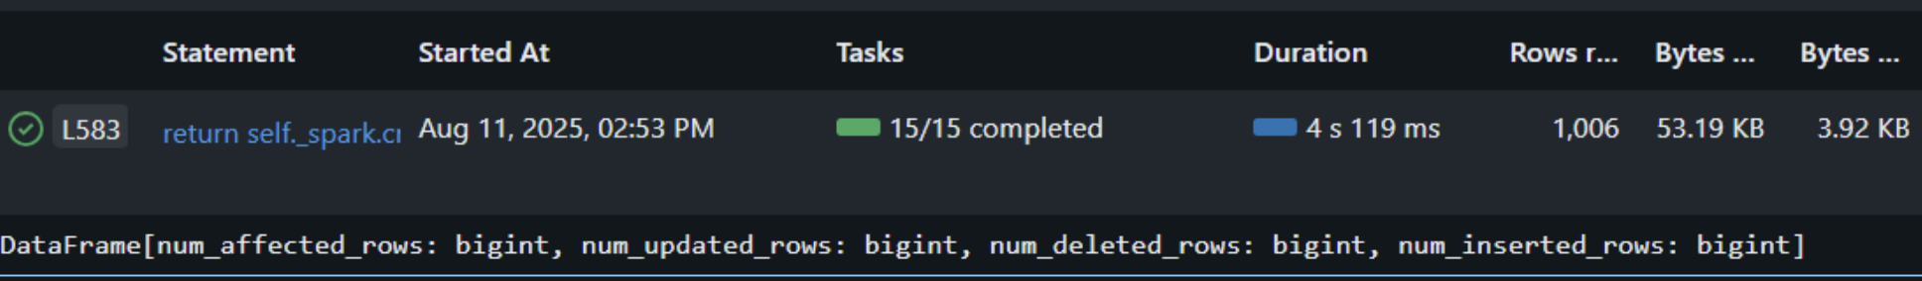

Read Data from the Delta Table
To verify the upsert operation, we read and display all data from the Delta table.

spark.sql("SELECT * FROM employees ORDER BY id").show()

